**DBMS ASSIGNMENT 4 PART-A**

**Name:-Ayush Mondal**

**Stream:-CSE**

**Semester:-4th Sec:-A Group:-1**

**Enrollment No.:-2011200001017**

**Registration No.:-200010170880**

**create table sailor(**

**sid varchar2(4) primary key check(sid like 's%'),**

**sname varchar2(15) check(sname=initcap(sname)),**

**mname varchar2(15),**

**surname varchar2(15) not null,**

**rating number(2) default 0,**

**age number(3,1) not null**

**);**

**desc sailor;**

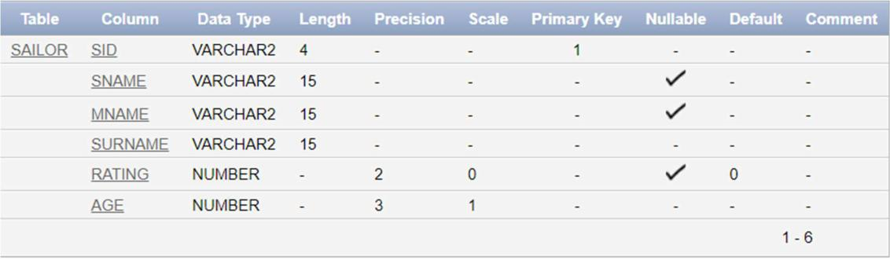

**insert into sailor values('s22', 'Fredrico',' ','Roberts',7,45); insert into sailor values('s31', 'Lubber',' ','Sheen',8,55.5); insert into sailor values('s32', 'Charlotte',' ','Gordin',8,25.5); insert into sailor values('s58', 'Mary','Beth','Lyon',10,35); insert into sailor values('s64', 'Horatio',' ','Powell',7,35.4); insert into sailor values('s71', 'Zorba',' ','Alex',10,16); insert into sailor values('s29', 'Brutus',' ','Slater',1,33.8); insert into sailor values('s95', 'Deep','Graceb ','Davis',3,63.5); insert into sailor values('s74', 'Horatio',' ','Forrest',9,35); insert into sailor values('s85', 'Sara',' Art','Powell',3,25.5); insert into sailor values('s80', 'Deep','Kumar ','Kumar',6,17); insert into sailor values('s87', 'Deep',' Kumar','Jha',8,51);**

**select *from sailor;**

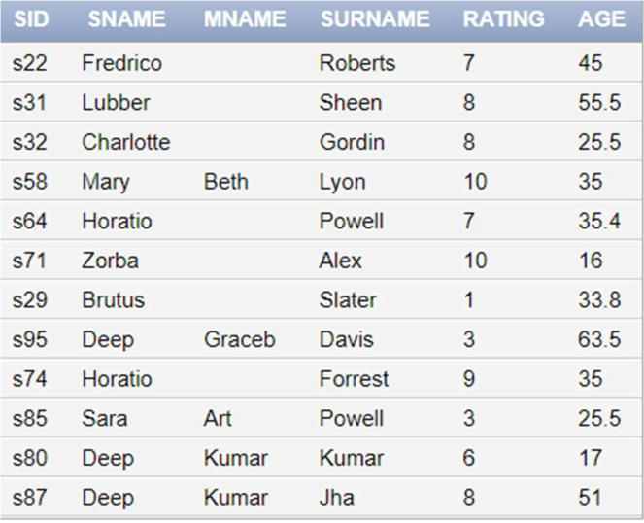

**create table boat(**

**BID varchar2(4) primary key check(BID like 'b%'), BNAME varchar2(10) check(BNAME=UPPER(BNAME)), COLOR varchar2(6) check(COLOR IN ('red','green','blue')) );**

**desc boat;**

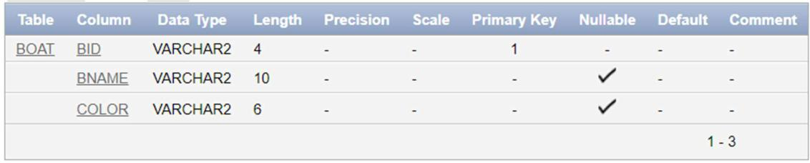

**insert into boat values('b101' , 'INTERLAKE', 'blue');**

**insert into boat values('b102' , 'INTERLAKE', 'red');**

**insert into boat values('b103' , 'CLIPPER', 'green');**

**insert into boat values('b104' , 'MARINE', 'red');**

**select *from boat;**

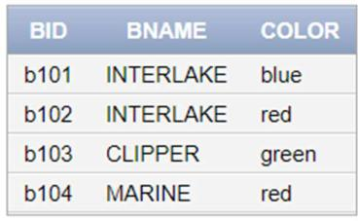

**create table sailor_boat(**

**sid varchar2(4) references sailor(sid),**

**bid varchar2(4) references boat(bid),**

**r_day date check(r_day < '1-JAN-2000'),**

**primary key(sid, bid));**

**desc sailor_boat;**

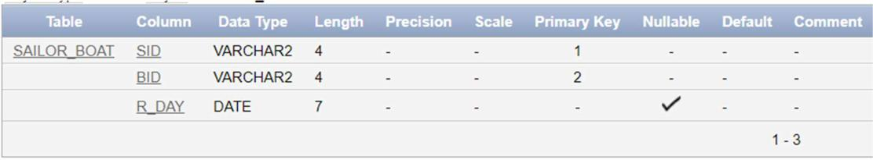

**insert into sailor_boat values('s22', 'b101', date'1998-10-10'); insert into sailor_boat values('s22', 'b103', date'1998-08-10'); insert into sailor_boat values('s22', 'b102', date'1998-10-10'); insert into sailor_boat values('s22', 'b104', date'1998-07-10'); insert into sailor_boat values('s31', 'b102', date'1998-10-11'); insert into sailor_boat values('s31', 'b101', date'1998-06-11'); insert into sailor_boat values('s31', 'b104', date'1998-12-11'); insert into sailor_boat values('s64', 'b101', date'1998-05-09'); insert into sailor_boat values('s64', 'b102', date'1998-08-09'); insert into sailor_boat values('s74', 'b103', date'1998-08-09'); insert into sailor_boat values('s80', 'b102', date'1998-07-07'); insert into sailor_boat values('s87', 'b101', date'1998-07-08'); insert into sailor_boat values('s87', 'b102', date'1998-12-12');**

**select sid, bid, to_char(r_day, 'DD-MON-YY') as r_day from sailor_boat order by sid, bid;**

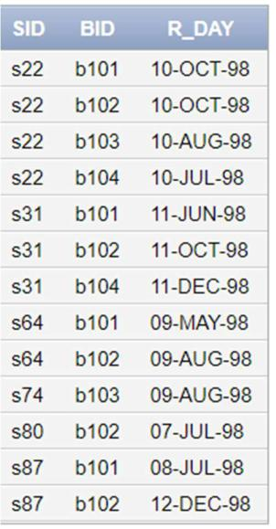

**Query:-**

* 1. **Find the names and ages of all sailors.**

**select sname || ' ' || mname || ' ' || surname as name, age from sailor;**

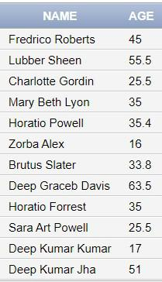

* 1. **Show names under the heading of names_of_sailors and add 2 to age.**

**select sname || ' ' || mname || ' ' || surname as names_of_sailors, age+2 as age from sailor;**

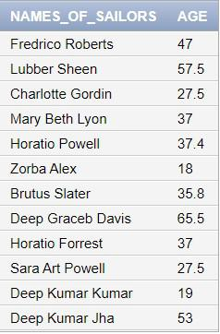

1. **Select all records from sailors in ascending order by name;**

**select * from sailor order by sname||mname||surname;**

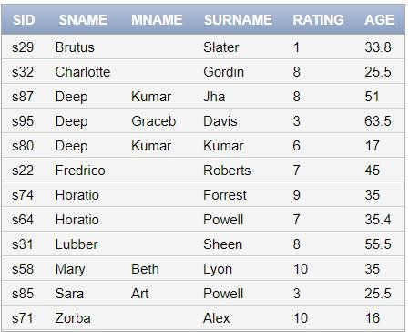

* 1. **Show all sailors name.**

**select sname from sailor;**

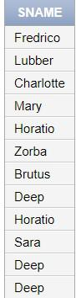

* 1. **Select all distinct sailors name.**

**select distinct sname from sailor;**

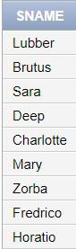

**6) Show all distinct sailors names, ratings who have rating between 5 and**

**10.**

**select distinct sname, rating from sailor where rating between 5 and 10;**

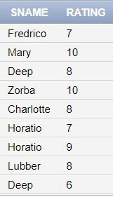

1. **Select all records from sailors in ascending order by rating and descending order by age.**

**select * from sailor order by rating, age desc;**

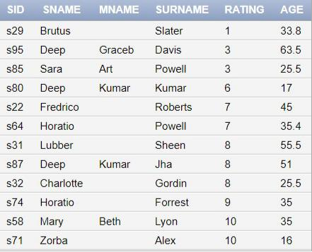

1. **Select all records from sailors whose rating>7.**

**select * from sailor where rating > 7;**

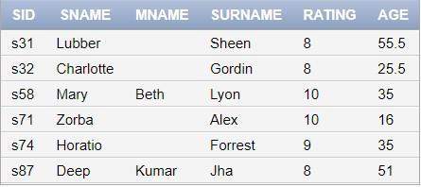

**9) Find records for sailor name Horatio and age=35.4.**

**select * from sailor where sname='Horatio' and age = 35.4;**

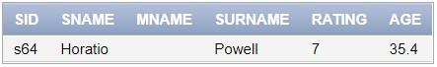

1. **Find records for sailor name Horatio or age=35.4.**

**select * from sailor where sname='Horatio' or age = 35.4;**

1. **Select names of sailors who have reserved boat b104.**

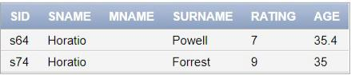

**select sname || ' ' || mname || ' ' || surname as name from sailor where sid in (select sid from sailor_boat where bid = 'b104');**

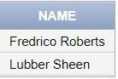

**12) Find sid of sailors who have reserved red boat.**

**select distinct sid from sailor_boat natural join boat where color = 'red';**



**13) Select records for name beginning with ‘B’.**

**select sname || ' ' || mname || ' ' || surname as name from sailor where sname like 'B%';**

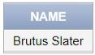

**14) Select records for name containing ‘B’/’b’.**

**select sname || ' ' || mname || ' ' || surname as name from sailor where sname||mname||surname like '%B%' or sname||mname||surname like '%b%';**

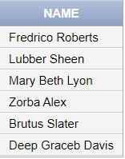

**15) Select names for rating present.**

**select sname || ' ' || mname || ' ' || surname as name from sailor where rating is not null;**

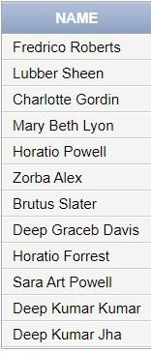

**16) Select names for rating absent.**

**select sname || ' ' || mname || ' ' || surname as name from sailor where rating is null;**



**17) Find color of boats reserved by Lubber.**

**select distinct color from boat natural join sailor_boat natural join sailor where sname = 'Lubber';**

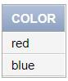

**18) Find a sailor name that have reserved at least one boat.**

**select distinct sname || ' ' || mname || ' ' || surname as name from sailor natural join sailor_boat;**

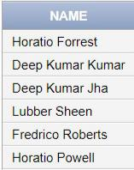

1. **Compute the increments of rating of persons who have sailed on diff boats on the sameday.**

**update sailor set rating = rating +1 where sid in ( select sid from sailor_boat group by sid, r_day having count(*) >= 2 );**

**select * from sailor;**

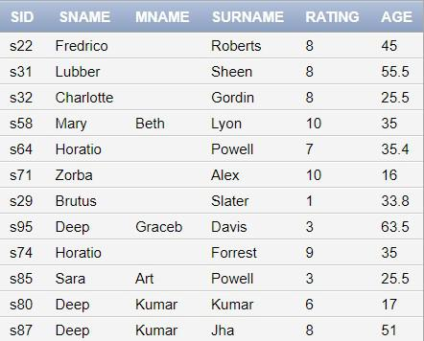

1. **Find name of sailors whose name begins and ends with B and has at least 3 characters.**

**select sname from sailor where sname like 'B_%b';**

1. **Find name of sailors whose name begins and ends with B and has exactly 3 characters.**

**select sname from sailor where sname like 'B_s';**

1. **Find names of sailors who have reserved a red boat or a green boat.**



**select distinct sname || ' ' || mname || ' ' || surname as name from sailor natural join sailor_boat natural join boat where color in ('red', 'green');**

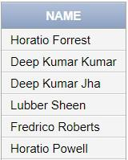

**24) Find names of sailors who have reserved a red boat but not a green boat.**

**select sname || ' ' || mname || ' ' || surname as name from sailor natural join sailor_boat natural join boat where color = 'red' minus**

**select sname || ' ' || mname || ' ' || surname as name from sailor natural join sailor_boat natural join boat where color = 'green';**

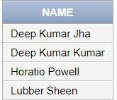

**25) Find names of sailors who have reserved boat b103.**

**select distinct sname || ' ' || mname || ' ' || surname as name from sailor natural join sailor_boat where bid='b103';**

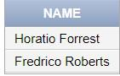

**26) Find names of sailors who have reserved red boat.**

**select distinct sname || ' ' || mname || ' ' || surname as name from sailor natural join sailor_boat natural join boat where color='red';**

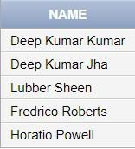

**28) Find names of sailors who have not reserved red boat.**

**select sname || ' ' || mname || ' ' || surname as name from sailor natural join sailor_boat natural join boat minus**

**select sname || ' ' || mname || ' ' || surname as name from sailor natural join sailor_boat natural join boat where color = 'red';**

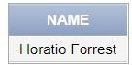

1. **Count distinct sailor name from sailors.**

**select count(distinct sname) as count from sailor;**



1. **a) Find all records for the rating>some sailor name where sailor name like ‘Horatio’.**

**select * from sailor where rating > any (select rating from sailor where sname =**

**'Horatio');**

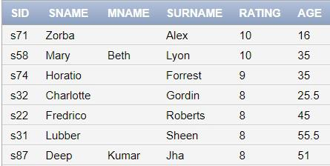

1. **Find all records for the rating>all sailor name where sailor name like ‘Horatio’.**

**select * from sailor where rating > all (select rating from sailor where sname = 'Horatio');**

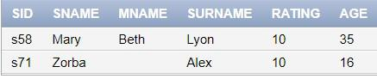

1. **a) Find all records for the rating<some sailor name where sailor name like ‘Horatio’.**

**select * from sailor where rating < any (select rating from sailor where sname =**

**'Horatio');**

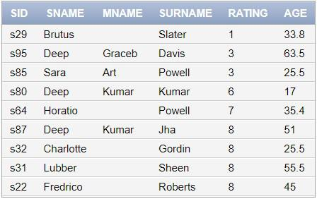

1. **Find all records for the rating<all sailor name where sailor name like ‘Horatio’.**

**select * from sailor where rating < all (select rating from sailor where sname = 'Horatio');**

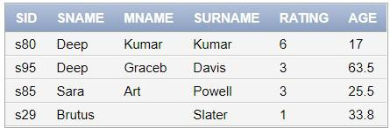

1. **Select all records for s_name neither Lubber nor Horatio.**

**select * from sailor where sname not in ('Lubber', 'Horatio');**

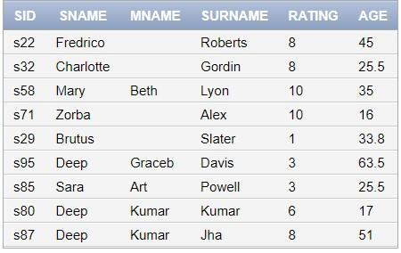

1. **Find names of sailors whose rating is>10/20/30 using multirow subquery operator.**

**select sname || ' ' || mname || ' ' || surname as name from sailor where rating > any**

**(10, 20, 30);**



1. **Find names of sailors whose rating is>10 & 20 & 30 using multirow subquery operator.**

**select sname || ' ' || mname || ' ' || surname as name from sailor where rating > all**

**(10, 20, 30);**



1. **Find average age of sailors with rating 10.**

**select avg(age) from sailor where rating = 10;**

1. **Find the name of sailor who are older than oldest sailor of rating=10.**

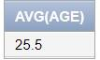

**select sname || ' ' || mname || ' ' || surname as name from sailor where age > (select max(age) from sailor where rating = 10);**

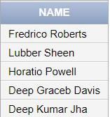

1. **Find the age of youngest sailor for each rating level.**

**select rating, min(age) as age from sailor group by rating;**

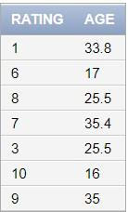

1. **Find the name of each sailor who is eligible to vote for each rating level.**

**select sname || ' ' || mname || ' ' || surname as name from sailor where age>=18 order**

**by rating asc ;**

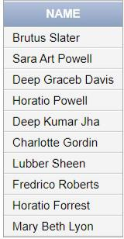

1. **Find the age of youngest sailor who is eligible to vote for each rating level with at least two such sailors.**

**select rating, min(age) as age from sailor where age >= 18 group by rating having**

**count(*) >=2;**

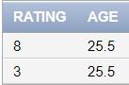

1. **Find the average age of sailor for each rating level with at least two such sailor.**

**select rating, avg(age) as age from sailor group by rating having count(*) >=2;**

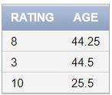

**41) For each red boat count the no of reservations for this boat.**

**select bid, count(*) as reservations from boat natural join sailor_boat group by bid, color having color = 'red';**

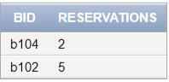

**42) Find sailor with highest rating.**

**select sid from sailor where rating = (select max(rating) from sailor);**



1. **Find those rating for which the average age of sailors is minimum over all rating.**

**select rating from sailor group by rating having avg(age) <= all(select avg(age) from sailor**

**group by rating);**

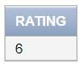

**45) Find sailors who have reserved all boats.**

**SELECT sid FROM sailor_boat minus (SELECT sid FROM ((SELECT * FROM ((select distinct**

**sid from sailor_boat) cross join (select bid from boat))) minus (SELECT sid, bid FROM sailor_boat)));**

